**COMP 1004**

**COMPUTING PRACTICE**

**2023/2024**

**Making a 2D car game**

**Introduction**

The project plan for the COMP1004 course project is in this paper. A lot of planning goes into this job. Beginning to make a 2D game with HTML, JavaScript, CSS, and JSON, this project wants to give players a simple but fun gaming experience. After the software development lifecycle, the iterative steps of design, coding, and testing will be carefully gone through, using different development methods to make the game better. The report will put light on bigger issues that are related to game development, such as social, legal, and moral issues. System requirements and design will be spelled out in great detail, and sprint plans will show how to implement the system step by step. The project's progress will then be critically assessed. With this project, the goal is to add to the world of gaming by making an easy but interesting 2D experience.

**Software Development Lifecycle**

Software Development Lifecycle is a structured method by which software engineers devise, develop, construct, verify, and maintain software systems in operation. Each step contributes to the successful development and implementation of high-quality software products through its own set of tasks and outputs (Noname Security, n.d.). For my project, I will be using **Waterfall Model**. It’s one of the oldest and most widely used model follows simple and straightforward methodologies, completing one phase before moving on to the next. This model was popular in early game development when requirements were constant. However, requirements change daily, making this model unsuitable. Useful for small game projects (www.studytonight.com, n.d.).

[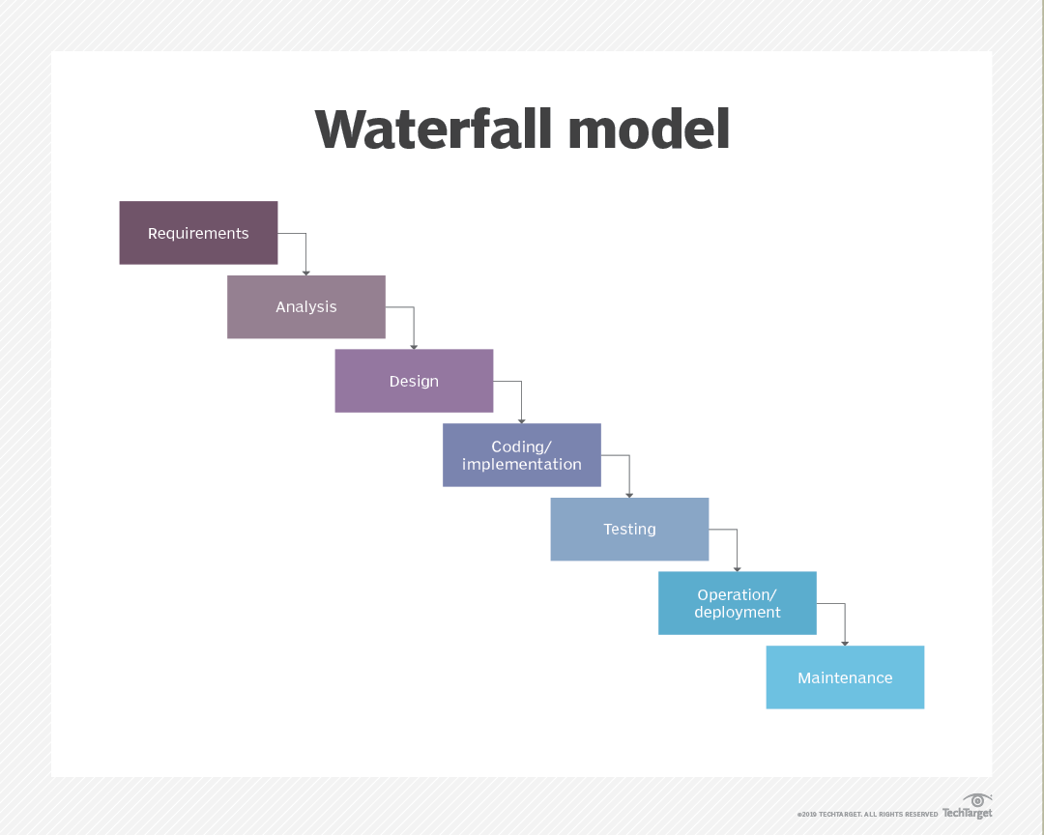](https://www.techtarget.com/searchsoftwarequality/definition/waterfall-model#:~:text=The%20waterfall%20model%20uses%20a,be%20revisited%20after%20their%20completion.)

*(SearchSoftwareQuality, n.d.)*

I had to brainstorm and think about the game I want to make. Initially, I was planning to make a Mortal Kombat style game but that will take way too long and too way too much work to actually make one. Finally, I am planning to make a 2D car game.

Sprint plan:

|  |  |  |
| --- | --- | --- |
| Number | Date | Plan |
| 1 | 8/11/2023 | Set up the basic project structure and design the main game screen.   * Set up the project repository and version control. * Create a simple HTML structure for the game screen. * Implement basic CSS styling for the game interface. |
| 2 | 22/11/2023 | Implement the core game mechanics and player controls.   * Integrate a basic 2D game engine or framework. * Implement player movement controls. * Design a simple track for the game. |
| 3 | 05/12/2023 | Enhance the gaming experience with background music and obstacles   * Implement collision detection between the player and track boundaries. * Add basic obstacles on the track. * Ensure the player can't move off the track. * Integrate background music for the game. |
| 4 | 19/12/2023 | Enhance the gaming experience with graphics and animations.   * Integrate basic graphics for the player's vehicle. |
| 5 | 31/01/2024 | Reworking game menu UI   * Making start |
| 6 |  |  |
| 7 |  |  |
| 8 |  |  |

Sprint Review:

|  |  |  |
| --- | --- | --- |
| Sprint Number | Achievements | Feedback |
| Sprint 1 | * Successfully set up the project repository and version control. * Created a basic HTML structure for the game screen. * Implemented fundamental CSS styling for the game interface. | * The initial setup is on track. * Ensure that the HTML and CSS structure align with the desired user interface. |
| Sprint 2 | * Integrated a basic 2D game engine or framework. * Implemented player movement controls. * Designed a simple track for the game. | * Core game mechanics are in place. * Ensure smooth player movement and track responsiveness |
| Sprint 3 | * Implemented collision detection between the player and track boundaries. * Added basic obstacles on the track. * Ensured the player can't move off the track. * Integrated background music for the game. | * Gameplay experience has improved with the addition of obstacles and background music. |
| Sprint 4 | * Integrated basic graphics for the player's vehicle. * Implemented animations for player movement and interactions. | * Visual and interactive elements have been enhanced, contributing to a more engaging experience. |

**Design Document**

The

**Project Vision**

**Background**

**User stories and Associated Use Case Scenarios**

UML Class Diagram:

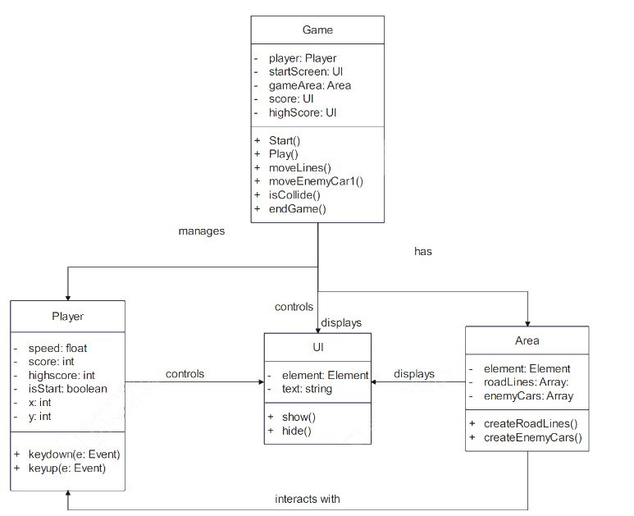

**Architecture**

**Sitemap**

**References**

Noname Security. (n.d.). What is SDLC (Software Development Lifecycle)? [online] Available at: <https://nonamesecurity.com/learn/what-is-sdlc/> [Accessed 29 Nov. 2023].

[www.studytonight.com](http://www.studytonight.com). (n.d.). *Game Development Lifecycle Models | Studytonight*. [online] Available at: <https://www.studytonight.com/3d-game-engineering-with-unity/game-development-models#:~:text=In%20Game%20development%2C%20the%20typical> [Accessed 30 Nov. 2023].